**NAAN MUDHALVAN PROJECT**

**Voyage Vista : Illuminating Insights From Uber Expeditionary Analysis**

**College : Arignar Anna Government Arts College For Women, Walajapet.**

**Ranipet District-632 513.**

**Department of Mathematics**



**Topic : Voyage Vista : Illuminating Insights From Uber Expeditionary Analysis**

**Submitted By**

**Team Leader : Nowshami.s**

**Team Members :**

1. **Mangaiyarkarasi.G**
2. **Meena.E**
3. **Nivetha.V**
4. **Nowshami.S**

**INTRODUCTION**

The ride-sharing business revolutionized a business model that had been functioning in the same way for generations: On a busy city street, a person in need of a ride stood on a street corner and waved down a taxi. On quieter streets, or in towns without roving taxis, the person would phone a local car service and request a pickup.

**OVER VIEW:**

Uber is a ride-hailing company that relies heavily on data science and analysis to support its day-to-day operations and provide hassle-free rides and deliveries to customers. Data science is a critical component of Uber's operations, and the company invests heavily in its data science and technology capabilities.

**Uber links passengers with drivers using the Uber app. Generally, the drivers own their own car. The company does also offer rental or lease on cars through third party partners like Hertz, Get Around and Fair. UberFleet is an app for those managing squads of driver**

**A BRIEF DESCRIPTION ABOUT OUR PROJECT:**

**Uber is a transportation company with an app that allows passengers to hail a ride and drivers to charge fares and get paid. More specifically, Uber is a ridesharing company that hires independent contractors as drivers.**

1. **Uber is a multinational transportation network company that operates a ride-hailing platform. It was founded in 2009 by Garrett Camp and Travis Kalanick and is based in San Francisco, California. Uber provides a convenient way for individuals to request rides from drivers who use their own personal vehicles.**

1. **Uber Driver Analysis refers to the Analyzing the number of trips taken by Uber drivers can provide insights into their overall activity and the demand for rides in specific areas. Daily, Weekly, or Monthly Analysis: Uber's data can be analyzed on a daily, weekly, monthly basis to understand the trends and patterns of trip volumes**

**.**

1. **This analysis can help identify peak hours or days of high demand and optimize driver availability during those times. Trips can be analyzed based on geographic regions or specific cities to identify areas with higher demand.**

1. This analysis can help Uber drivers decide where to focus their driving efforts for maximum efficiency and profitability. The Major of our project is to use data Analyzing techniques to find unknown patterns in the Uber Drives dataset. The research is carried out on Uber drives data collected from the year 2016.

**PURPOSE**

This analysis can help identify peak hours or days of high demand and optimize driver availability during those times. Trips can be analyzed based on geographic regions or specific cities to identify areas with higher demand.

**This is more of a data visualization project that will guide you towards using the ggplot2 library for understanding the data and for developing an intuition for understanding the customers who avail the trips.**

**Most analytics teams will focus on: Building big data collection and analytics capabilities to uncover customer, product, and operational insights. Analyzing data sources and proposing solutions to strategic planning problems on a one-time or periodic basis. Providing data-driven decision support.**

**The purpose of data analysis is to gain meaningful insights from raw data to support decision-making, identify patterns, and extract valuable information.**

Data analysis can provide a snapshot of what students know, what they should know, and what can be done to meet their academic needs.

**USES OF THIS PROJECT:**

With more than 8 million users, 1 billion Uber trips and 160,000+ people driving for Uber across 449 cities in 66 countries – Uber is the fastest growing startup standing at the top of its game. Tackling problems like poor transportation infrastructure in some cities, unsatisfactory customer experience, late cars, poor fulfilment, drivers denying to accept credit cards and more –Uber has “eaten the world” in less than 5 years and is a remarkable name to reckon when it comes to solving problems for people in transportation.

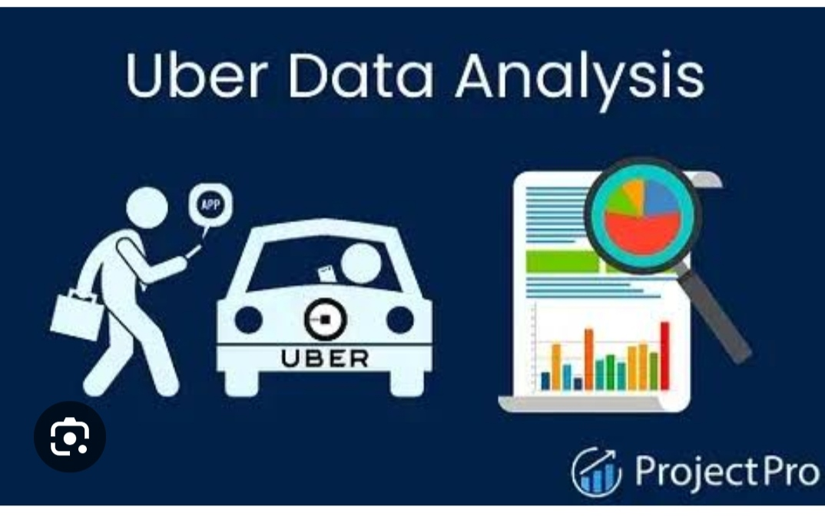

If you have ever booked an Uber, you might know how simple the process is –just press a button, set the pickup location, request a car, go for a ride and pay with a click of a button. The process is simple but there is a lot going on behind the scenes. The secret key driving growth of the $51 billion start-up, is the [big data](https://www.projectpro.io/article/top-20-big-data-project-ideas-for-beginners-in-2021/426) it collects and leverages for insightful and intelligent decision making. While Uber moves people around the world without owning any cars, data moves Uber. With the foundation to build the most intelligent company on the planet by completely solving problems for riders –Big Data and Data Science are at the heart of everything Uber does - surge pricing, better cars, detecting fake rides, fake cards, fake ratings, estimating fares and driver ratings. Read on to understand how Uber makes clever use of big data and data science to reinvent transportation and logistics globally.

Big Data at Uber

“Uber lives or dies by data. Their overall mission and their sustainability is completely dependent on how good their data is. The more data they can collect, the more information they can derive from patterns and behaviours. Their ability to increase profits is all dependent on that.”- said Spencer, a former Uber driver.

There is no need to look for a local taxi or to tip a bellman for the ride, you are just a click away from a high quality customer experience with Uber’s revolutionizing data driven business model. Data is the biggest asset for Uber and its complete business model is based on the big data principle of crowdsourcing. Anybody with a car willing to help someone get to a desired location can offer help in getting them there.

It is tricky to get sufficient details on Uber’s big data infrastructure but we have some interesting information here about Uber’s big data. Uber’s data is collected in a [Hadoop data lake](https://www.projectpro.io/article/data-lake-vs-data-warehouse-is-the-warehouse-going-under-the-lake/283" \o "What is a Data Lake" \t "_blank) and it uses [spark and hadoop](https://www.projectpro.io/article/hadoop-vs-spark-not-mutually-exclusive-but-better-together/235) to process the data. Uber’s data comes from a range of data types and databases like SOA database tables, schema less data stores and the event messaging system, Apache Kafka

Uber is greedy about what data it collects and with many cheap relative storage options like Hadoop and Spark-it has got data about every single GPS point for every trip taken on Uber. Uber stores historic information about its system and capabilities to ease doing data science for its [data scientists](https://www.projectpro.io/article/how-to-learn-data-science-from-scratch-on-your-own-in-2021/420)down the road. Keeping the change logs, versioning of database schemas helps data scientist answer every question on-hand. With the data Uber has, [data scientists can answer questions](https://www.projectpro.io/article/how-to-prepare-for-a-data-scientist-interview/233) like what did the Uber system look like at a particular point of time from a customer perspective, supply behaviour perspective, from inter-server communication perspective or even to the state of a database.

Data Science at Uber

Data science is an integral part of Uber’s products and philosophy. Uber does an exceptional job of hiring data-oriented people throughout the company through its exclusive Uber Analytics test v3.1. Any individual applying a job at Uber that requires analysing back-end extract from the application, has to take the Uber Analytics Test.

Recommended Reading: Top 20 Data Analytics Projects for Students to Practice in 2021

On the product front, Uber’s data team is behind all the predictive models powering the ride sharing cab service right from predicting that “Your driver will be in here in 3 minutes.” to estimating fares, showing up surge prices and heat maps to the drivers on where to position themselves within the city.The business success of Uber depends on its ability to create a positive user experience through statistical data analysis. What make Uber unique is that the data science driven insights don’t just stay within the dashboards or company reports but they are implemented in real-time into its to create a positive user experience for customers and drivers

**Data Products at Uber - Surge Pricing**

To create the most efficient market and maximize the number of rides it can provide –Uber uses surge pricing. You are running late and stressed enough to take the public transport, Uber could come to your rescue, and however you soon notice that they will charge you 1.5 times more than the usual rate.

Sometimes when you try to book an Uber, and what you thought would be a $10 ride is going to be 2 or 3 or even 4 times more – this is due to the surge pricing algorithms that Uber implements behind the scenes. Data Science is at the heart of Uber’s surge pricing algorithm. Given a certain demand, what is the right price for a car based on the economic conditions. The king of ride sharing service maintains the surge pricing algorithm to ensure that their passengers always get a ride when they need one even if it comes at the cost of inflated price. Uber has even applied for a patent on big data informed pricing i.e. surge pricing.

Most of the predictive models at Uber follow the business logic on how pricing decisions are made. For instance, the Geosurge (name for surge pricing or dynamic pricing model at Uber) looks at the data available and then compares theoretical ideals with what is actually implemented in the real world. Uber’s surge pricing model is based on both geo-location and demand (for a ride) to position drivers efficiently. Data science methodologies are extensively used to analyse the short term effects of surge pricing on customer demand and long term effects of surge pricing on retaining customers. Uber depends on regression analysis to find out which neighbourhoods will be the busiest so it can activate surge pricing to get more drivers on the roads.

Uber recently announced that it’s going to limit the use of surge pricing through machine learning. The machine learning algorithms will take multiple data inputs and predict where the highest demand is going to be so that Uber drivers can be redirected there. This will ensure that there is no supply and demand shortage so that it does not have to actually implement surge pricing. Uber has not yet confirmed as to when this new

**Uber Data Science Tools:**

Python is the go-to data science programming language at Uber and is extensively used by the Uber data team. Commonly used third party modules to do data science at Uber include NumPy, SciPy, Matplotlib and Pandas. Uber data team does use R programming language, Octave or Matlab occasionally for prototypes or one-off data science projects and not for production stack. D3 is the most preferred data visualization tool at Uber and Postgres, the most preferred SQL framework.system with smart machine learning algorithms would be rolled out to reduce surge pricing.

**PROBLEM DEFINITION AND DESIGN THINKING:**

**EMPATHY MAP:**

An empathy map is a collaborative tool teams can use to gain a deeper insight into their customers. Much like a user persona, an empathy map can represent a group of users, such as a customer segment. The empathy map was originally created by Dave Gray and has gained much popularity within the agile community.

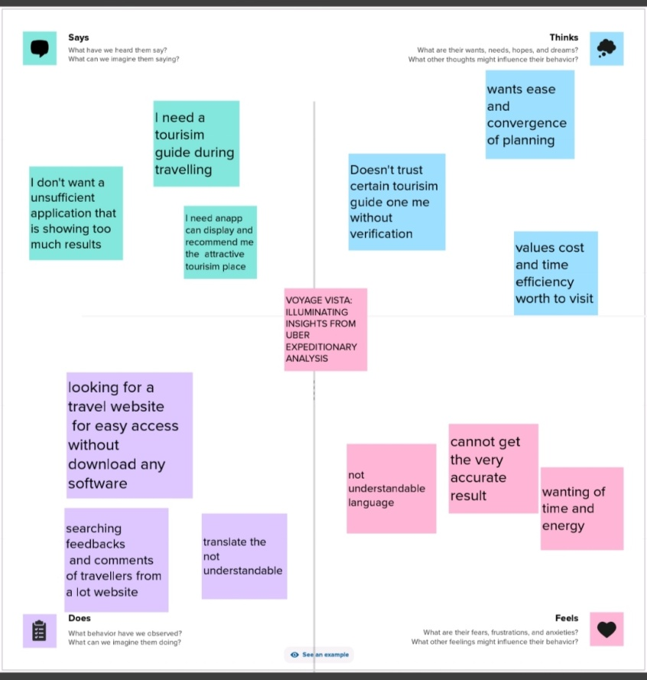

**IDEATION AND BRAINSTORMING MAP:**

An ideation mind map is a visual diagram that helps you organize and structure your thoughts and ideas. It works by creating a central idea or concept and then breanching out into smaller, related that connect to the central idea.

**A mind map is a visualization technique and brainstorming tool which allows you to explore a central idea, and all of its related topics, in a non-linear way. When brainstorming, or attempting to see a particular topic from all angles, linear tools — like lists — aren't always the best solution.**

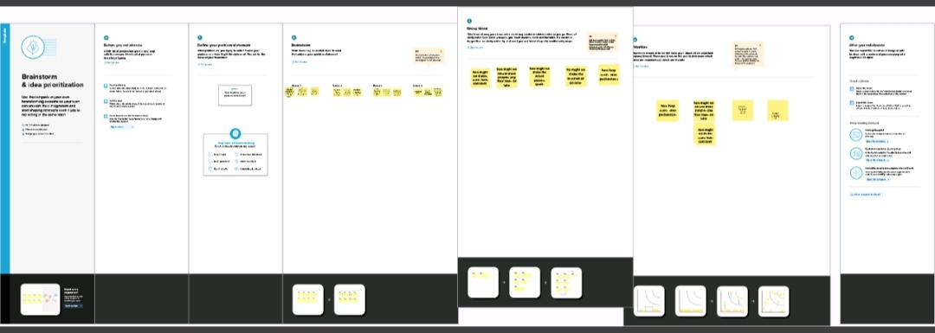

**RESULT:**

RESULTS At the end of all procedure we get to see different graphs giving us unbelievable insights. We have plotted different graphs as mentioned below:

UBER TRIPS: Quarter of end data

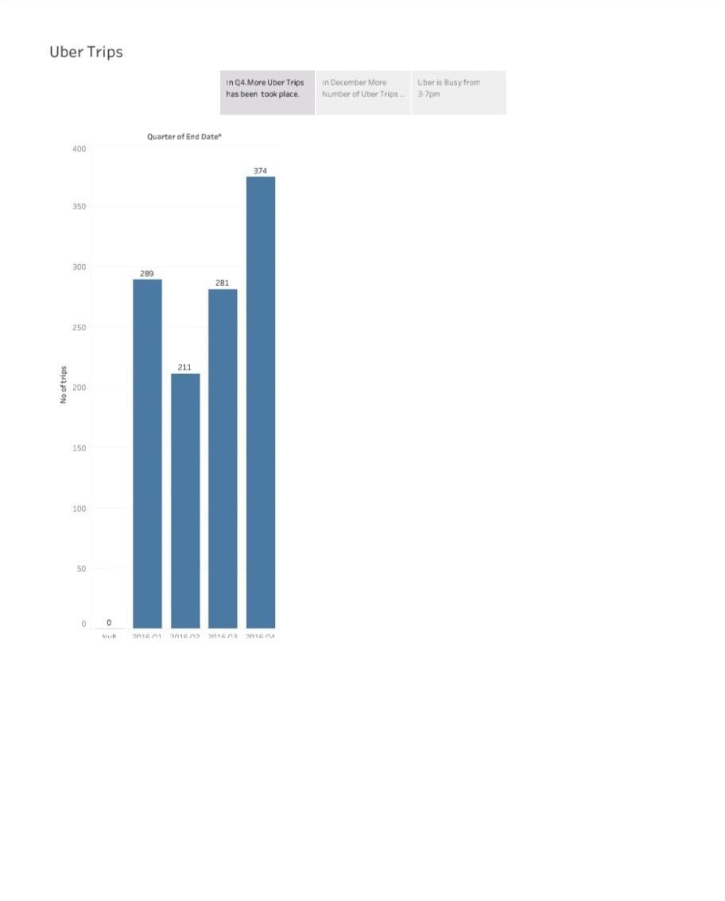

**END DATA:**

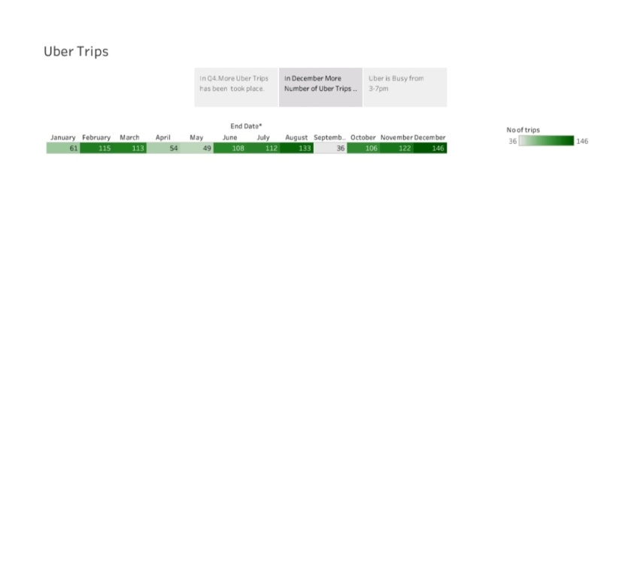

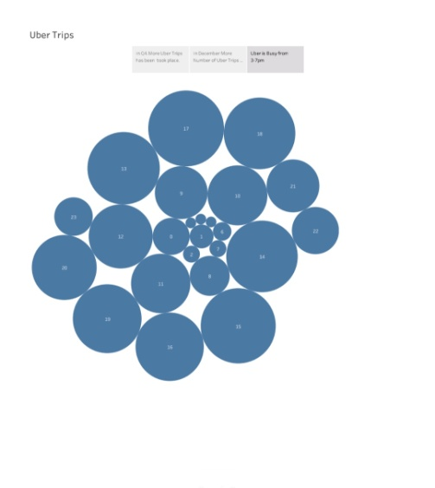

**DASHBOARD :1**

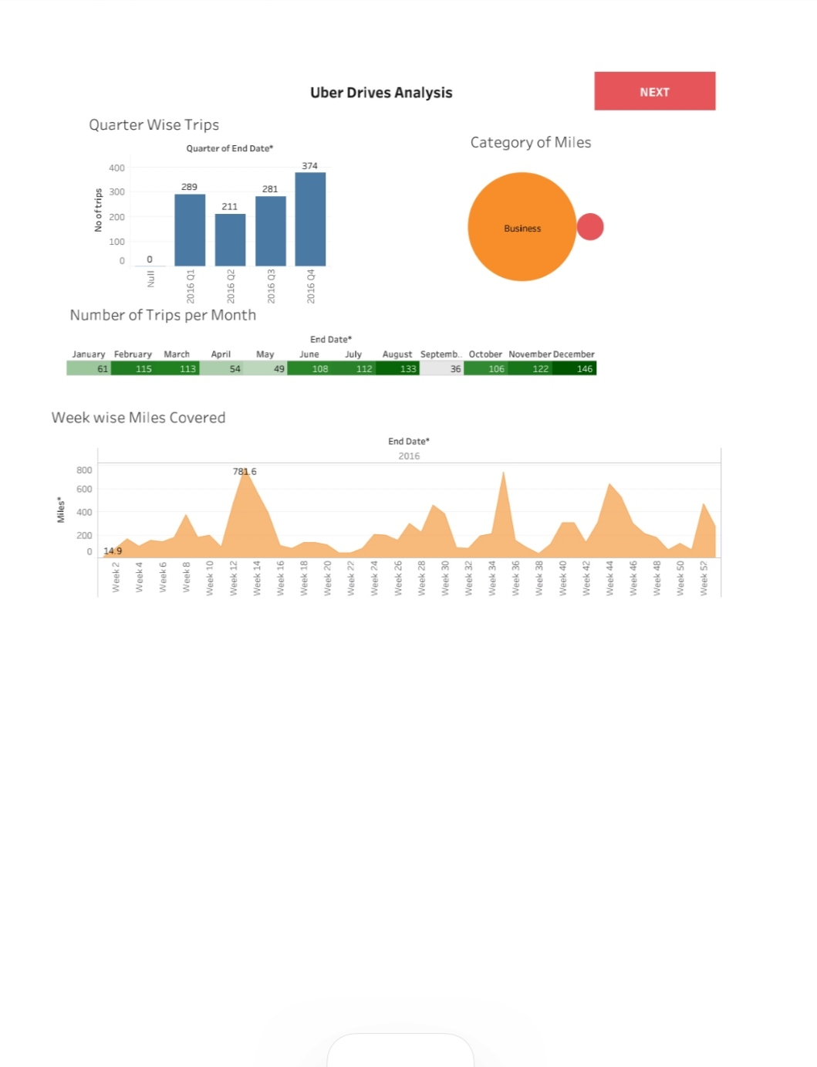

**DASHBOARD:2**

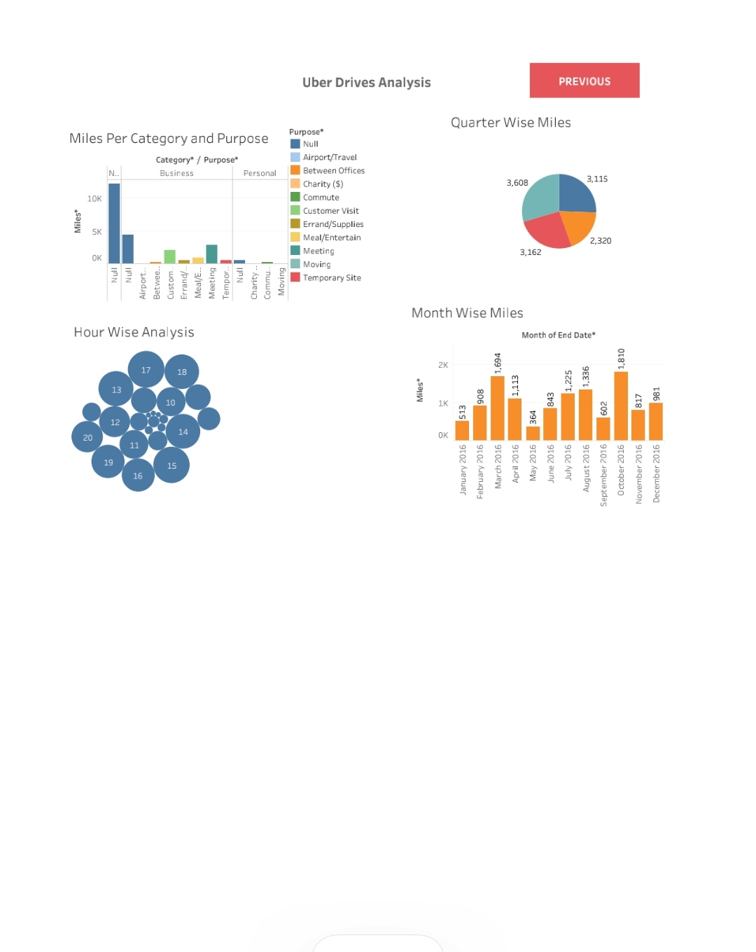

**ADVANTAGES AND DISADVANTAGES:**

## Uber: An Overview

The ride-sharing business revolutionized a business model that had been functioning in the same way for generations: On a busy city street, a person in need of a ride stood on a street corner and waved down a taxi. On quieter streets, or in towns without roving taxis, the person would phone a local car service and request a pickup.

Now, there's an app for that.

E-hail services like [Uber](https://www.investopedia.com/articles/personal-finance/111015/story-uber.asp) allow you to hire a driver using a smartphone from almost any location at any time. ("Almost" because drivers are in short supply in outer suburbs and rural areas.)1 Proprietary software locates drivers circling nearby and generally offers a selection of options, from the cheapest carpooling choice to luxury wheels. The price is set and paid in advance.

Uber's famous "[surge pricing](https://www.investopedia.com/terms/p/peak-pricing.asp)" revises the cost of its rides from hour to hour based on local demand.2 As more calls are made, prices tick up, drawing more drivers out to score customers. As demand subsides, prices tick down.

Bright-yellow taxicabs once dominated the streets of Manhattan. By 2020, there were four times as many ride-sharing vehicles on the streets as taxis. Those vehicles were summoned by apps offered not only by Uber and Lyft but by Via, Juno, and Gett.

Clearly, Uber and its competitors such as Lyft have dramatically changed the personal transportation industry, with a mix of both benefits and drawbacks for customers and drivers. Let's look at them.

### KEY TAKEAWAYS:

* Ride-sharing services like Uber have disrupted the taxi and limo industry,
* Uber has become a prime example of the gig economy at work.
* Uber's advantages include door-to-door convenience, safety, and reliable quality.
* Uber's disadvantages include its surge pricing and the negative effects of replacing steady jobs with gig work.

## Convenient and Cashless

Instead of chasing down a taxi on a street, or calling and waiting for a car service, e-hail app users can hail a car from any location and have it arrive in minutes. Uber doesn't even need to ask you for an address. It knows where you are.

## Professional Service

Drivers for Uber and its competitors use their own cars, and they seem incentivized to keep them clean and well-maintained. The cheapest options are late-model compacts, not junkers.

The riders input their destinations into the app, and the drivers use navigational software to get there. Wrong turns are unlikely.

The drivers are generally polite and well-spoken. They never refuse to take you to any particular destination. They don't even know your destination before they accept your call.

Does this sound like a case of damning with faint praise? That depends on what city or cities you were accustomed to catching taxis in.

Unprofessional drivers are weeded out because passengers get to rate the driver’s performance. A consistently low rating will force a driver out of Uber or its competitors.

All of the above and more foster a positive experience for ride-sharing customers.

## Competitive Pricing

It is impossible to come up with a definitive or average price for an Uber. Its pricing scheme varies with every city, and that surge pricing model changes the prices constantly based on demand.3

According to Consumer Reports, longer trips are generally cheaper by Uber but short trips can be more expensive. And the vast majority of trips by Uber are short.4 So, an Uber ride from the airport to a suburb should save you money, but a mile-long trip across a neighborhood could well be cheaper in a cab and would definitely be cheaper by bus or subway.

Consumer Reports also warns that the surge pricing model for both Uber and Lyft can mean much higher prices at busy times of the day.4

The bottom line: Uber can be less expensive than a taxi or car service, but not consistently. One point in its favor, though, is that Uber tells you exactly what the prices will be for the options available at that time before you confirm the trip.

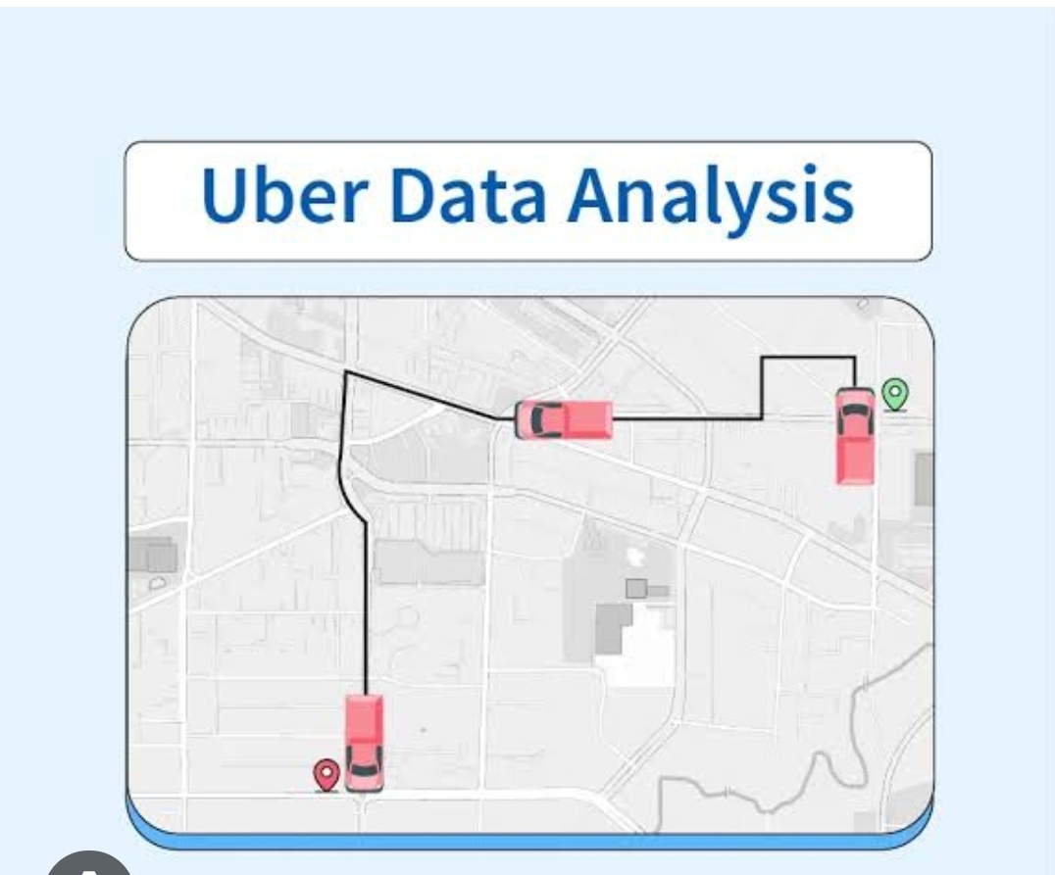

## Safety and Flexibility For Drivers

Safety is an important advantage for drivers working with Uber and other e-hail services. The riders using the service have registered their identities and their credit card numbers on the app. They are not random strangers on the street.

Because the transaction is cashless, a driver doesn't risk unpaid fares or need to carry cash for change.

Rude, aggressive, and disruptive passengers are weeded out because drivers rate their customers. Consistently low ratings or reports of unsafe behavior toward drivers can cause the deactivation of an account.5

Unlike yellow cab taxi drivers who work 12-hour shifts or black car drivers who are scheduled by dispatchers, Uber drivers enjoy considerable freedom and flexibility. Drivers log in and out of the system anytime they choose and pick their own hours.6

Drivers avoid expensive taxi rental leases by using their own vehicles. They also pay their own fuel and maintenance costs. All else being equal, this may mean more profit for drivers.

Drivers are also spared any office politics because the app renders dispatchers irrelevant.

## Controversial Labor Practices

Uber has become a prime example of the [gig economy](https://www.investopedia.com/terms/g/gig-economy.asp) at work. Its workers are not guaranteed a minimum wage, they have to supply and maintain their own vehicles, and have few if any benefits.

That is becoming controversial in some cities where Uber operates. In 2018, New York City mandated a $17.22 minimum wage for drivers.7 In 2019, California legislators passed [California Assembly Bill 5 (AB5)](https://www.investopedia.com/california-assembly-bill-5-ab5-4773201#citation-6), a law classifying ride-sharing drivers as employees, not independent contractors, but the state's voters later reversed that by voting in Uber-sponsored [Proposition 22](https://www.investopedia.com/california-proposition-22-prop-22-5085852) in November 2020

## Surge Pricing

"Surge pricing" for Uber, or "prime time pricing" as it is called by Lyft, is controversial among customers. It's a classic use of the free market principle of raising or lowering prices according to supply and demand. For Uber customers, this means how many cars are available (supply) and how many passengers want to ride in them (demand).

Compared to a straightforward surcharge, this automated system can lead to quite dramatic differences in pricing between any two points. At super peak times, a price could double or triple. That can mean a hefty expense during rush hour or during a snowstorm.

Safety concerns have emerged in some cities and states where the transportation industry regulations are lax and it's easy to enter the e-hail network as service providers. Although this has a positive effect by increasing the supply of drivers, these drivers might not be as motivated to reach high standards of professionalism and safety.

## Negative Impact of Price Competition

Price competition can be destructive for any industry. Increasingly, [Uber, Lyft,](https://www.investopedia.com/articles/personal-finance/010715/key-differences-between-uber-and-lyft.asp)and other e-hail services are engaged in an intense battle to provide the cheapest service. They are directly competing with each other, and with traditional taxi and car services for both customers and drivers.

With competition from other ride-sharing services and the continuous hiring of new drivers, average earnings are being pushed downward. This means that drivers have to work longer hours to earn an income comparable to what they would have earned a year or two ago.

This has led to a precipitous drop in earnings for taxi drivers, too. Prices for New York City taxi medallions, essentially a metal permit to drive a cab, plummeted from about $1.3 million to $160,000 over a few years, leaving drivers scrounging for rides and drowning in debt.

**APPLICATIONS:**

Uber Technologies Inc.'s ([UBER](https://www.investopedia.com/markets/quote?tvwidgetsymbol=uber)) explosive growth and seemingly endless controversies have made it one of the most fascinating companies to emerge over the past decade and a half. Its global ride-sharing app, launched in 2009, [disrupted](https://www.investopedia.com/terms/d/disruptive-technology.asp) modern transportation as we know it, at one point making Uber the most valuable startup company in the world.

Ten years after its founding, Uber went public on May 9, 2019. Though the road has been bumpy, Uber remains the major company in the ride-sharing space. In its most recent annual earnings release, for 2022, Uber reported a total of 7.6 billion trips, $31.9 billion in revenue, and a net loss of $9.1 billion.

### KEY TAKEAWAYS

* Today's leading ride-hailing app by far, Uber Technologies was founded in 2009 and quickly became the world's most valuable startup.
* Uber's disruptive business model, explosive growth, and constant controversies have made it one of the most fascinating companies to emerge in recent years.
* Before its highly anticipated IPO in 2019, Uber was valued at as much as $120 billion by investors. But after going public on May 9, 2019, it made history with the biggest first-day dollar loss in U.S. history.
* Since then, Uber has worked on becoming profitable, in part through the acquisition of other companies.

## An Idea Is Born

As the company tells it, Uber's story begins in Paris in 2008. Two friends, Travis Kalanick and [Garrett Camp](https://www.investopedia.com/tech/garrett-camp-uber-founder-crypto-inventor/), were attending LeWeb, an annual tech conference that The Economist describes as "where revolutionaries gather to plot the future."1 In 2007, both men had sold startups they co-founded for large sums. Kalanick sold Red Swoosh to Akamai Technologies for $19 million, while Camp sold StumbleUpon to eBay ([EBAY](https://www.investopedia.com/markets/quote?tvwidgetsymbol=ebay)) for $75 million.

The concept for Uber was born one winter night during the conference when the pair was unable to get a cab. That led to an epiphany: "What if you could request a ride from your phone?" Initially, the idea was for a timeshare limo service that could be ordered via an app. After the conference, the men went their separate ways. However, when Camp returned to San Francisco, he continued to be fixated on the idea and bought the domain name UberCab.com.1

## The Early Years

In 2009, Camp was still CEO of StumbleUpon, but he began working on a prototype for UberCab as a side project. By summer of that year, Camp had persuaded Kalanick to join as UberCab's "chief incubator." The service was tested in New York in early 2010 using only three cars, and the official launch took place in San Francisco that May. The company soon shortened its name to Uber.

Ryan Graves, who was Uber's general manager and an important figure in the early stages of the company, became CEO of Uber in early 2010. In December 2010, Kalanick took over as CEO, while Graves took on the title of general manager and senior vice president of global operations.

The ease and simplicity of the Uber app fueled its rising popularity. With the tap of a button, a user could order a ride, GPS would pinpoint their location, and the fare would be automatically charged to the card listed on the user account.

## From 2015 to Today

In July 2015, Uber became the most valuable startup in the world, valued at $51 billion after its funding rounds. In June 2016, Uber then raised a further $3.5 billion from Saudi Arabia's sovereign wealth fund.

In April 2017, Uber opened up about its finances for the first time to Bloomberg and reported a global loss of $3.8 billion for 2016. This included losses from its China business, which it sold in the summer of 2016—without it, net adjusted losses were $2.8 billion.6

By the following year, the firm's valuation had been knocked down from a lofty $68 billion to $48 billion. In 2018, Japanese conglomerate SoftBank Group, along with a group of investors including Dragoneer Investment Group, successfully bid for 20% of Uber's stock at this lower valuation, a 30% discount on the last valuation figure. The deal reportedly gave SoftBank a 15% share in the company, while Uber got a powerful ally in Asia that could help turn the tide for it after a few very public missteps. The remaining shares reportedly went to other investors in the group.

This period was also marked by other challenges, including the fatal crash of a self-driving vehicle from Uber's fleet. Additionally, in August 2018, New York City Council voted to put a pause on new licenses issued to ride-hailing services such as Uber and Lyft.7

Uber's May 2019 [IPO](https://www.investopedia.com/terms/i/ipo.asp) made history as the biggest first-day dollar loss in IPO history in the United States. At one point, Uber was valued at $120 billion by Wall Street analysts, which would have made it the largest company ever to debut on the stock market. After the IPO, it was valued at about $69 billion—just over half of its high-hopes IPO.

### Claims of discrimination and harassment

In 2018, Uber paid approximately $7 million to more than 480 current and former employees to settle a 2017 lawsuit alleging gender discrimination, harassment, and a hostile work environment. The lawsuit claimed that Uber used a discriminatory ranking system that undervalued female employees and employees of color.

The complaints against Uber weren't limited to its employees. An arbitrator ordered Uber in April 2021 to pay $1.1 million to Lisa Irving, a blind customer. The arbitrator ruled that Uber's drivers had discriminated against Irving by denying her rides or verbally abusing her more than a dozen times. Uber had argued that it was not responsible for the drivers' actions because of their independent contractor status.23

## Uber's Acquisitions and Other Business Units

Uber derives a significant portion of its revenue from its investments and from services other than its basic ride-hailing app. Those include:

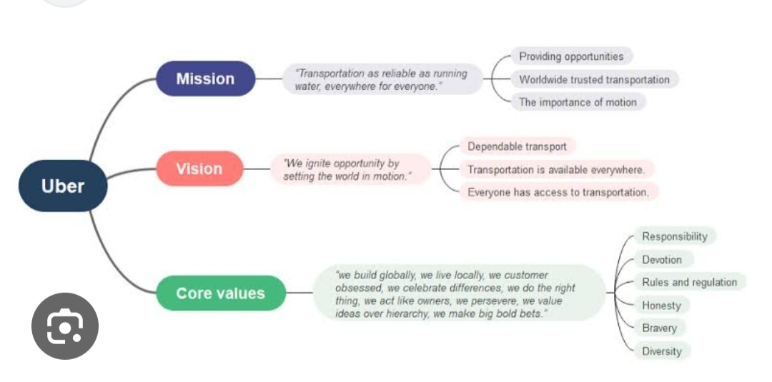

### Lime scooters

In July 2018, Uber announced that it would be investing in the electric scooter rental company Lime, in collaboration with Alphabet Inc.'s GV ([GOOG](https://www.investopedia.com/markets/quote?tvwidgetsymbol=goog)).27 Lime's lightweight scooters are available for rent in a number of major cities, and customers leave them on the sidewalk for the next rider, making for a convenient and clean-energy-based business model. Uber users can book a scooter through their Uber app.28

## How Much Do Uber Drivers Make?

As Uber notes on its website, "The money you make driving with the Uber app depends on when, where, and how often you drive."31 The job website Indeed puts the median hourly pay for Uber drivers at $17.98.32

## Which Is Bigger, Uber or Lyft?

In terms of both market share and market capitalization, Uber is considerably bigger than Lyft. In mid-April 2023, Lyft's market cap stood at $3.8 billion, compared with Uber's at over $63 billion.338

## Where Did Uber Get Its Name?

The Wall Street Journal reports that, "Uber's name comes from the German word über, meaning "over, above."34

## The Bottom Line

Well over a decade since its founding, Uber remains one of the most closely followed and fastest growing companies in the world. At the same time, it continues to struggle to attain profitability, especially in its core ride-hailing business.

## CONCLUTION:

In general, the example offered by Uber can be used by many developing companies. Nowadays, it is not a difficult task to create an organization and introduce some new, unusual services. However, it is always challenging to gain a good reputation, prove the quality of the services, and create appropriate working conditions.

Uber is the company with a complicated history. Still, its founders had made something that was impossible: they survived sabotages, strikes, and discontents of the governments of different countries around the whole world. The necessity to provide people with good services at affordable prices is urgent nowadays. Not all people are able to use the quality they want. Uber opens new perspectives and possibilities.

However, its attempts to cooperate with big cities only are not enough to become one of the best. It is necessary to make more improvements and encourage changes. Drivers are eager to work at different places. Uber can provide drivers with jobs and citizens with transportation services. The factors for success and challenges discussed in the current paper show that Uber as all chances to succeed in international marketing. The only thing that the company has to do is to continue developing and thinking about its employees.

**FUTURE SCOPE:**

We can use this data for training a model using ML and building a smart AI based predictive system. Model can automatically send the insights to the authorities or drivers related to areas having most trips and passenger count in certain areas. This big data can be used to study passenger’s behavior.

Uber stock price stood at $45.99 According to the latest long-term forecast, Uber price will hit $55 by the middle of 2024 and then $65 by the end of 2025. Uber will rise to $70 within the year of 2026, $85 in 2027, $95 in 2028, $100 in 2030, $110 in 2032 and $125 in 2035.

Uber Data Analysis through Visualisations in R  
  
With the help of visualization, companies can avail the benefit of understanding the complex data and gain insights that would help them to craft decisions.

enterprise. It subsequently underwent rapid growth within a very short amount of time. Since its establishment, other comparable companies have sprung from the same idea or something very close to it. At present, there are at least a dozen companies to rival Uber. However, even with all the competition, Uber is the largest in terms of the variety of services available, where it operates, and market valuation. Uber is available in 58 countries and over 400 cities, with a market valuation speculated as high as $70 billion. Uber’s story of success did not happen without controversy. Regardless, Uber is now on everyone’s radar—regulators, academia and those who need to get to their destination. This paper aims to focus on Uber’s business model, and describe it relative to other types of transportation services. This paper addresses the business model’s fundamental advantages and disadvantages, the variety of controversies surrounding it, and offers some predictions and concluding remarks.

**APPENDEX:**

**SOURCE CODE:**

Supporting wide range of Data Lifecycle Operations for a variety of datastores used by Uber, ranging from: Offline Data Stores like HDFS. Online Data Stores such as MySQL, Schemaless, Cassandra, DocStore. Cloud Data Stores from Public Cloud Providers (Cloud Object Storage in AWS/GCP)

Open source software underpins much of Uber's technology stack. Our teams also actively contribute to and develop software in the areas of artificial intelligence, deep learning, mobile development, data visualization, and infrastructure.